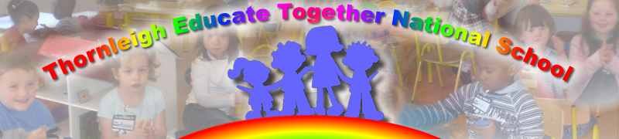

Dear Parents and Guardians

By now you may have heard the news that our children are required to wear face coverings from today to help stop the spread of Coivd 19 and more importantly to keep us all safe. I am attaching the information I HAVE RECEIVED from the Department of Health with regard to this.

If you do not have a face mask for tomorrow please do your best to have them all by Monday or sooner if possible from 3rd to 6th class.

Below are some points from NPHET:

NEPHT has recommended the wearing of face masks/coverings by children aged nine years and over – they have recommended that this is introduced in 3rd class and over.
Face masks are intended to prevent transmission of the virus from the wearer to those with whom they come into contact with.

Exemptions
A medical cert to certify that a person falls into the category listed below must be provided to the school on behalf of any pupil who claims that they are covered by the exemptions below:

- Any pupil with difficulty breathing or other relevant medical conditions
- Any pupil who is unable to remove the cloth face-covering without assistance
- Any pupil who has special needs and who may feel upset or very uncomfortable wearing the cloth face covering
- Parents should be advised that they obtin face masks for their child which fit properly and are comfortable for the child to wear. If the child forgets or loses the school will supply same in exceptional circumstances only

- Schools have not been provided with extra funding to supply masks.
We have also attached the guidance for effective use of masks,

Children are required to have the face masks on coming to school at the school gate before they enter the school.

I appreciate this is new for a lot of our children and I also appeal to your sense of keeping your child and all in school safe while we all get through this tough time in the world.
I thank you for your understanding and cooperation.

Paula Carolan
Principal
1st December 2021.

