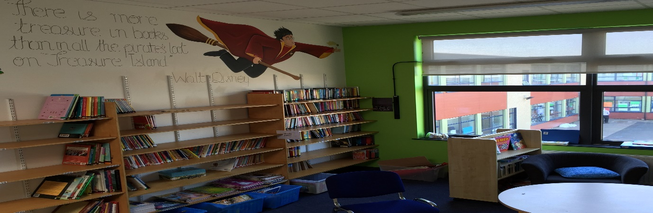Good morning to all Parents, Guardians, students and friends of Thornleigh

Happy International Women’s Day 2021

We have had a really successful first week back at school. The children and staff are really happy to be back in the building again and teaching learning both within and outside of the classroom. There have been lots of PE lessons, literacy lessons, maths lessons and Art lessons going on outside.

We have also started our Walk for Water whereby the children are walking a mile a day fin order to help schools in Tanzania install running water. We do not realise how lucky we are in Ireland and Thornleigh to have running water at our fingertips especially in these times. Let us all take a moment of gratitude to pause and reflect on all the good we have in our lives…………………
All participants will receive our new 'Hope' bracelets, which were made for us by our partners in Tanzania's Morogoro region, the Childhood Development Organisation.
So far you have raised €605.00 on our online collection – thank you.

We are so looking forward to seeing all the 3rd – 6th class students next week. A reminder to come on time – not before or after – and not to congregate outside the school gates as you will not be admitted – for health and safety of all, as the Corona Virus is still out there – and may have to return home. Children are not required to wear masks but ALL adults who come to drop or collect children MUST WEAR A MASK. Thank you for your cooperation in this very important matter.

Have a lovely week and this week’s theme is – kindness.

Paula Juliet Carolan – Príomhoide – 8th March 2021.

