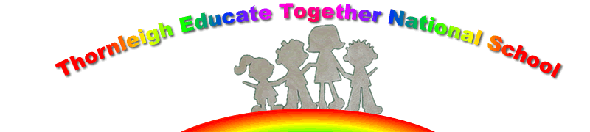

21st September 2022

Dear Parents

Welcome back to a new year in Thornleigh ETNS. We are looking forward to a great year of learning and activities for your children. Besides the Curriculum some of the activities your children will engage in are as follows:
- The Scarecrow Project – linked to wellbeing and World Mental Health Day
- Soup Day – our annual event – all children receive soup harvested from our school garden and linked to the Harvest Festival – all parents welcome to help
- Pantos – some of the children will be brought to the Panto either in Dundrum or The Gaiety – more information to follow – linked to literacy and culture
- Annual school tours
- Friday morning assemblies – the highlight of our week
- Christmas reading by Mrs Claus with Hot Chocolate to follow
- Marathon Kids –5th/ 6th class – linked to healthy lifestyle, literacy and SPHE – Social Personal and Health Education
- OWLS – outdoor and environmental learning – 2nd class
- Graduation of 6th class – 29th June 2022
- Nurture school
It was lovely to meet you all at our ‘Meet the Teacher and HSCL – Cathal’ over the last few weeks – these events are always important for you, your children and the staff here at Thornleigh – thank you for attending.
And a BIG THANK YOU to the parents who helped make Thornleigh Beautiful by clearing the weeds and debris from around the school grounds’ today (21st September 2022.

Home Learning

Here at Thornleigh we have a policy of ‘Home Learning’ rather than homework. Extensive research has proven that Homework is of little benefit, if any, to Primary school children. As a result, and being a progressive school, our policy of Home Learning is as follow –
Every Monday – Active Home Learning – 20 minutes of activity based learning – such as running, dancing, cycling, walking, football, games outdoors with friends etc. – this is then recorded in the child’s Home Learning Diary/Copy.
Reading – every night with or to your child, or independent reading in the older classes – books can be taken from our school library or the local library in Swords. Children engaging in Reading Recovery will have a book sent home with them.
In the older classes – Spellings for Me and Irish verbs
Junior and Senior Infants – word boxes/phonics
Project work

The only time children will have written work is if they have not completed it in class.

We wish all your children a wonderful 2022/2023 of learning and fun here in Thornleigh ETNS

Ms Paula and Staff.

